**P1**: Develop PEAS description of the task environment for a Candy Sorting Robot that can sort candies to the appropriate jars.(Lec1-2)

**P2**: A problem, 8-puzzle consists of a 3x3 board with eight numbered tiles and a blank space. A tile adjacent to the blank space can slide into the space. The objective is to reach the goal state. Is this problem well defined? If yes, then explain the four basic components of well-defined problem according to the 8-puzzle problem.( Lec 3.1)

**P3**: The A* algorithm is complete and optimal, why?

**P4**: The heuristic based algorithm in which the objective function is



What kind of search does this perform when w = 0? When w = 1? When w = 2?

**P5**: **(a)** Consider the given graph where you need to reach any of the destination nodes {G1, G2, G3} starting from node S. Find the path from S to any of the destination nodes with the least cumulative cost using a Uniform Cost Search.

**(b)** Is it possible to find the solution for the given graph using A* search? Explain your answer.

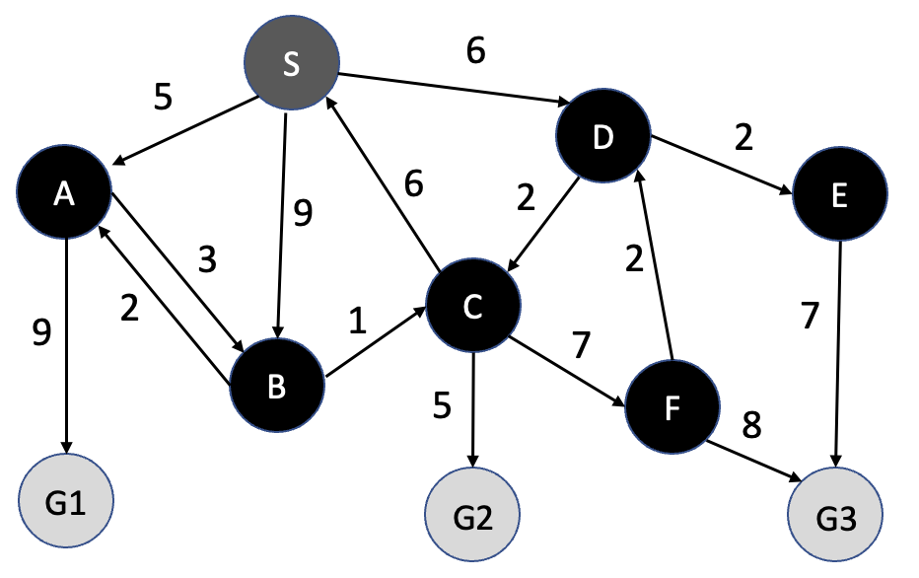

**P6: Show** the simulation [frontier, explored set, path(solution), Path Cost, Tree] using Iterative deepening. Start node S and goal node G. Insert the node in the frontier in alphabetic order. ( Lec 3.1)

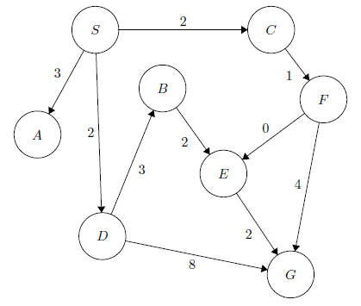

**P7**: 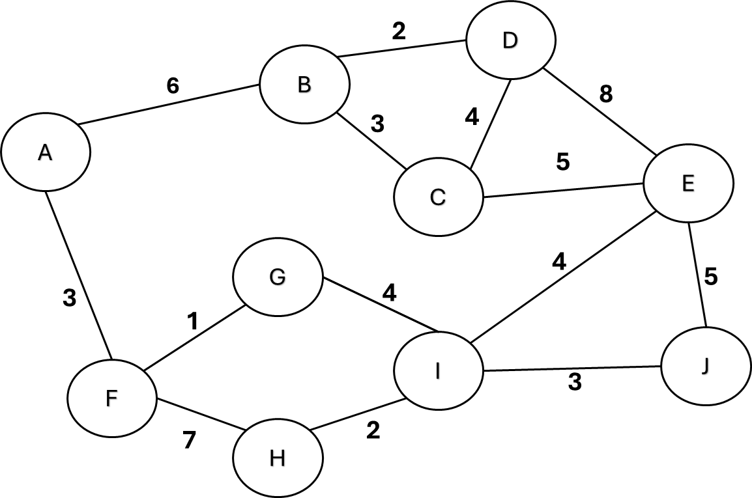

|  |  |
| --- | --- |
| **(a)** Consider the graph on the above, where you need to reach the destination node G starting from node D. Apply Uniform Cost Search. Show the steps of searching for the best path.  **(b)** Apply BFS in the same graph with the destination node G starting from node D. | |

P8: **a)** Show the simulation[frontier, explored set, path(solution), Path Cost, Tree] using BFS and DFS. Start node S and goal node G. Insert the node in the frontier in alphabetic order. ( Lec 3.1)

**(b)** Explain the completeness and optimality of BFS and DFS.

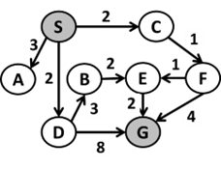

P9: Apply the α-β pruning algorithm to the search tree given in the right and show each update of α-β values clearly. Make sure that you show where the α and β cuts are applied, and which parts of the search tree are pruned as a result.

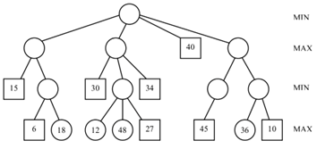

P10: Apply the α-β pruning algorithm to the search tree given in the right and show each update of α-β values clearly. Make sure that you show where the α and β cuts are applied, and which parts of the search tree are pruned as a result.

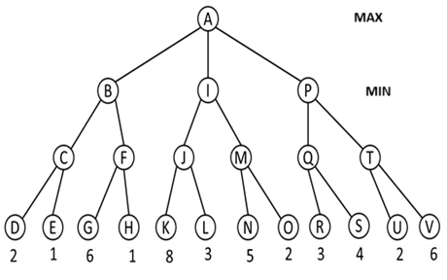

P11:  **(a)** Suppose we have a graph with nodes S, A, B, C, D and G, where S is the start and G the goal node. Perform an A* search for this problem. Recall that

f (n)= g (n)+h (n). The heuristic estimates of the distance to G are:

h(S)=22, h(A)=20, h(B)=8, h(C)=14, h(D)=11 and h(G)=0

**(b)** Apply the Greedy Best First Search (GBFS) algorithm to solve the below problem (Question P10).

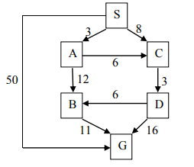

P12: Consider A is the starting state, and E is the goal state in the graph. The heuristic value h(n) is given besides node and the step costs are given in the edges. Find consistent heuristic for blank nodes and apply A* search , Greedy Best First Search for given graph. Recall

h(n)≤c(n, a, n`) + h(n`) .*𝒉𝒏≤𝒄(𝒏, 𝒂, 𝒏`) + 𝒉(𝒏`) .*

